

Personal and Industrial Property
Valuation Guidelines --
Trended Investment Method
For
January 1, 2019

If You Have Questions

For questions about these Guidelines or other personal and industrial property tax issues, contact:

Name | Title | Phone Number | E-Mail Address
Mary Burket | Personal Property Specialist | (360) 534-1368 | MaryBu@dor.wa.gov
Lisa Brewer | Valuation Specialist | (509) 987-1234 | LisaBr@dor.wa.gov

To access the 2019 Personal Property and Industrial Valuation Guidelines:
- Go to the Department of Revenue’s web site at www.dor.wa.gov.
- Select Find taxes and rates in the top middle of the screen.
- Select Property tax below the Find taxes and rates heading.
- In the main window select, Get property tax statistics, laws and rules, and other resources.
- Select Property tax publications.
- Scroll down and select either Personal Property Tax Valuation Guidelines or Industrial Valuation Guidelines.
- Select 2019.
Table of Contents

If You Have Questions 1
Valuation Tables – MS Excel Link 2
Purpose and Use of These Guidelines 3
Determining the Valuation Trend 5
Minimum Value Percent Good Factors 6
Other Exceptions to the Minimum Value Percent 6
Revisions and Clarifications to the 2019 Guidelines 6
Additional Comments 6
Possible Areas for Study in 2019 8
Suggesting Updates to the Guidelines 8
Additional Information and Personal Property Resources 9
Index to Trended Investment Valuation Indicators 11
Supplemental Valuation Table 'A' 18

Valuation Tables – MS Excel Link

 Double click on the MS Excel icon in the box below to access the “2019 Personal and
Industrial Property Valuation Tables.”

In the link, you will find:

DOUBLE CLICK BELOW

“2019 Personal and Industrial Property Valuation Tables”

- 2019 Combined Tables (All)
- 2019 Trend I Table
- 2019 Trend II and III Tables
- 2019 Building and Land Improvements Table
- 2019 Title Plant (Supplemental B)
- Informational – 2019 Trend with Freeze
- Informational – Declining Balance Tablethe e

Purpose and Use of These Guidelines

The Department of Revenue (Department) publishes valuation guidelines to assist county assessor’s offices with estimating assessed values for tangible personal and industrial property. The Department recommends assessors consider the guidelines in the valuation process in order to promote and contribute to statewide uniformity and standardization for the assessment of personal property.

The guidelines are based on typical physical depreciation and functional obsolescence for assets that have been maintained in average condition. If the appraiser is aware of market conditions, or has other evidence, adjustments to the estimated market values can be made. When identified, the obsolescence should be considered separately. Data and information must be able to substantiate any excessive obsolescence not already considered in the indicators.

To use the guidelines:
Step #1 – Find the class/type of property in the alphabetical index and note the indicated Trend/Column for that class/property type.
Step #2 –Find the corresponding Trend/Column the Index refers you to in the Combined Table.
Step #3 – Using the Combined Table, locate the “percent good factor” at the intersection of the acquisition year row and the indicated table/column for the property being valued.
Step #4 – Using the property owner’s personal property listing information; multiply the historical (or original) cost by the “percent good factor” to arrive at an estimated value as of January 1, 2019.

Example: Consider an Agricultural Tank (i.e. Tanks – Agricultural Tanks), Purchased in 2014 for $1,000

Steps #1 & #2

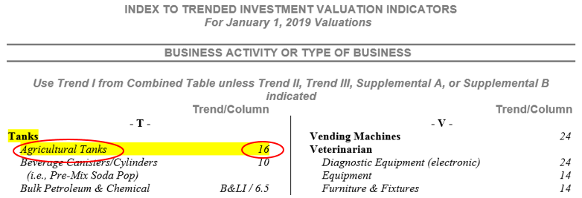

Step #3
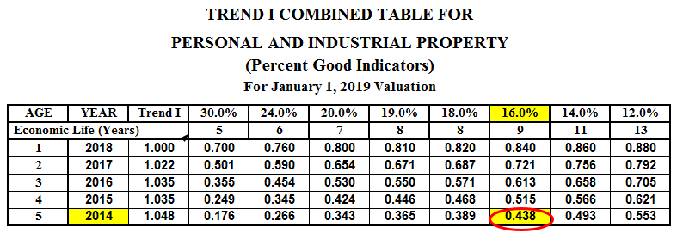

Step #4
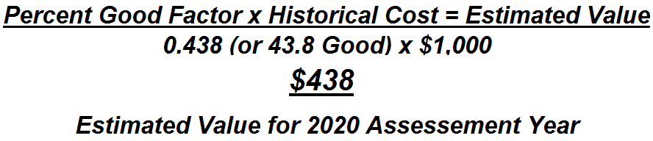

Note – The historical, or original costs, listed by the property owner need to include both hard and soft costs – such as interim financing during installation or construction, engineering, freight, installation, and any other costs necessary to put the equipment in to service. The only exclusion is sales (or use) tax, which is removed when valuing personal property.

Assets installed in a way that they become fixed to the real property, or their removal would cause significant damage to the real estate, might be regarded as real property. When valuing real property, sales (or use) tax should be included as a cost that adds value to the assets, except when there is a sales (or use) tax exemption that applies to qualifying manufacturing machinery and equipment as of the assessment date.

Determining the Appropriate Combined Trend Table

While the alphabetical index is comprehensive, instances occur when assets do not exist in the index. Therefore, use the following “Decision Flow Chart” as a guide to determine the appropriate combined trend table.
Decision Flow Chart
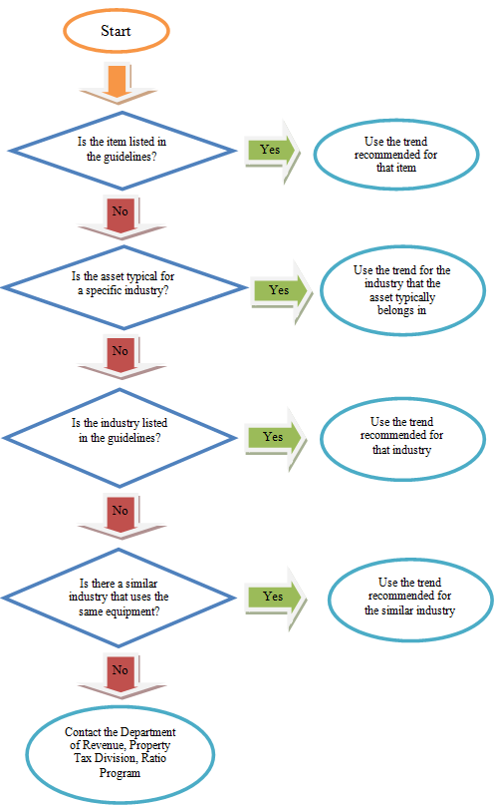

Minimum Value Percent Good Factors

Please note these guidelines are intended for estimating the value of property that is “in use.” The minimum value percent or factor is 15 percent, unless otherwise noted, as shown on the Combined Table, and is intended to reflect the value of assets for as long as they are in use (Fair Market Value In Continued Use). For assets not in productive use (such as those in storage), freight and installation may be excluded from the cost basis to determine the value. Most percent good factors on the Combined Table indicate a minimum value of 15 percent good; however, several exceptions exist, including those listed under Trend II tables C, B, N, S.

When the appraiser or auditor is aware of market conditions or other evidence (including, but not limited to, direction from court or board proceedings) to apply percent good factors below 15 percent, rates can be calculated and applied. Evidence must reflect the value in continued use at the retail trade level, as well as documented data and information must exist to substantiate a floor less than 15 percent.

Revisions and Clarifications to the 2019 Guidelines

Some “Business Activity or Type of Business” indexes were revised for 2019. The revisions provide clarification and update some terminology resulting from matters brought to the Department’s attention from stakeholders throughout the previous year. In some instances, revisions include updated studied industry information and available data. Revisions may also reflect advice the Department has provided for the assessment of particular equipment, utilizing the best information available for the appropriate economic life, until additional information becomes available, or until further study of the equipment. Changes for 2019 are denoted in Red font within the index portion of these guidelines:

Additional Comments and Considerations

- For locally assessed Electrical Generating Wind Turbines (Wind Farms) M&E, no changes for 2019.
- For Specialized Tooling used in the manufacturing of commercial airplanes, the following index can be utilized, taking into account guidance for specialized tooling unique to commercial airplane manufacturing that must be controlled for the lifetime of each commercial airplane model. Notably, FAA (Federal Aviation Administration) requires certification and inspection of specialized tooling used in the production of commercial airplanes for the entire lifecycle of the airplane program.
The term “tooling" here refers to articles of tangible personal property whether or not mechanized, including and similar to, but not limited to, dies, die blocks, fixtures, gages, molds, patterns, templates, jigs, and other manufacturing and inspection aids, specifically designed for use in manufacturing commercial airplanes or the components of commercial airplanes. Also, "tooling" encompasses an article(s) of tangible personal property, whether or not mechanized, that is part of a system that functions as a manufacturing and/or inspection aid if the article(s):
1. Is specifically designed for use in manufacturing commercial airplanes or components,
2. Cannot be used for purposes other than manufacturing commercial airplanes or components without substantial modification or alteration, and
3. Interacts with: a manufacturing or inspection aid, the system directly supporting such aids, or a commercial airplane or component worked on by the manufacturing or inspection aid.
For purposes of this section the terms “commercial airplane” and “component” have the meaning given to those terms in RCW 82.32.550. Additionally, the guidance applies only to the tooling noted above – and does not include other general tools, machining tools, non-tooling M&E, etc. used to manufacture commercial airplanes.

- To value Specialized Tooling, the commercial airplane manufacturer needs to provide a percent good factor for each airplane model manufactured, utilizing the formula below (from publicly available data). Apply that percent good to the applicable airplane model specialized tooling asset costs.
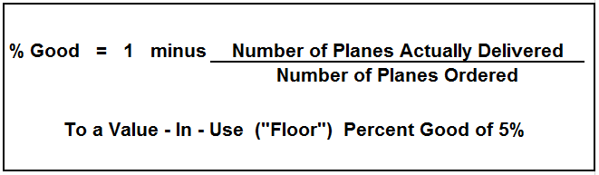

- Trend II/S table remains unchanged for respective business indexes. However, Microchip Manufacturing M&E “Process Support Equipment & Piping,” utilizes an “in use” (floor) value of 10 percent. Given limited application statewide, the actual table reflecting a 10 percent floor is not included as part of the guidelines. Rather, the below modified Trend II/S table should be applied:
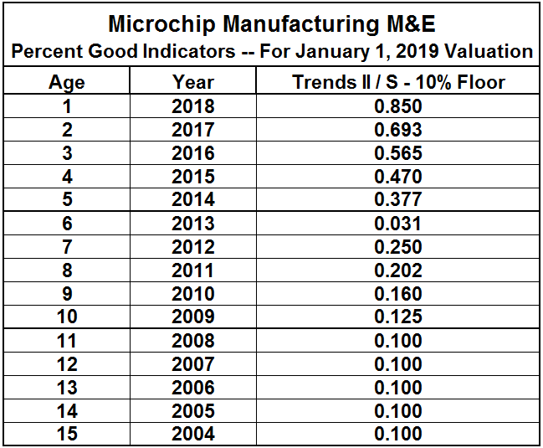

Possible Areas for Study in 2019

The Department regularly considers revisions to study, and would like additional and continued review in 2019 for the following:
- Billboards and Poster Panels (this is a carry-over area for study).
- Marijuana Equipment – given historical data is limited for this industry, the Department is currently reviewing its guidance specific to marijuana industry – especially as data and new information becomes available.
Review will include inviting stakeholders input for calibrating the tables for the indexes studied. If you would like to be part of the discussion to provide feedback, data, or information related to these areas, please contact the Department at (360) 534-1400.

Suggesting Updates to the Guidelines

We continually invite input to the guidelines and attempt to incorporate suggested ideas when updating the guidelines, keeping in mind the needs of all stakeholders and users of the guidelines.
- What needs to be fixed, added, or deleted in the Guidelines? Why? What do you recommend?
- Are there any guideline business activities in the indexes or tables that need to be revised? Why? What do you recommend, and what data can you provide to substantiate the revision?
- Are there any types of assets, or business activities, not listed in the index, that should be listed? If so, which ones? Why?
- Do you have data about any assets, business activity, or type of business that might help recalibrate an existing guideline?
Please provide any data or studies you have, as it is useful as we consider the information for updating the guidelines in the future. If you have any additional questions or comments, please contact the Department at (360) 534-1400.

Additional Information and Personal Property Resources

- Personal Property Tax Brochure – https://dor.wa.gov/sites/default/files/legacy/Docs/Pubs/Prop_Tax/PersProp.pdf
- Personal Property Tax Information Video – https://dor.wa.gov/workshops-education/watch-online-workshop-or-tutorial/personal_property_tax
- Property Tax Review (newsletter) articles related to personal property assessment:
  - Allocated vs. Historical Cost –https://dor.wa.gov/sites/default/files/legacy/Docs/Pubs/Prop_Tax/NewsletterSept2008.pdf
  - Closed Business Required to File? – https://dor.wa.gov/sites/default/files/legacy/Docs/Pubs/Prop_Tax/NewsletterSpring2007.pdf
  - Capital Improvements – https://dor.wa.gov/sites/default/files/legacy/Docs/Pubs/Prop_Tax/NewsletterQ122015.pdf
  - Farm M&E Exemption – https://dor.wa.gov/sites/default/files/legacy/Docs/Pubs/Prop_Tax/NewsletterQ122015.pdf
  - Fixed Loads vs. Part of Vehicle – https://dor.wa.gov/sites/default/files/legacy/Docs/Pubs/Prop_Tax/Winter2012Newsletter.pdf
  - Head of Family Exemption – https://dor.wa.gov/sites/default/files/legacy/Docs/Pubs/Prop_Tax/NewsletterSpring2007.pdf
  - Leased Equipment FAQs – https://dor.wa.gov/sites/default/files/legacy/Docs/Pubs/Prop_Tax/NewsletterSpring2009.pdf
  - Leasehold Improvements – https://dor.wa.gov/sites/default/files/legacy/Docs/Pubs/Prop_Tax/NewsletterQ12014.pdf
  - Mobile/Manuf. Homes (part 1) – https://dor.wa.gov/sites/default/files/legacy/Docs/Pubs/Prop_Tax/NewsletterWinter2013.pdf
  - Mobile/Manuf. Homes (part 2) – https://dor.wa.gov/sites/default/files/legacy/Docs/Pubs/Prop_Tax/NewsletterJune2013.pdf
  - Rental Equipment FAQs – https://dor.wa.gov/sites/default/files/legacy/Docs/Pubs/Prop_Tax/NewsletterSpring2010.pdf
  - Taxability of Software – https://dor.wa.gov/sites/default/files/legacy/Docs/Pubs/Prop_Tax/Winter2012Newsletter.pdf
  - Timeshare Assets – https://dor.wa.gov/sites/default/files/legacy/Docs/Pubs/Prop_Tax/NewsletterSummerFall2012.pdf
  - Title Plant FAQs – https://dor.wa.gov/sites/default/files/legacy/Docs/Pubs/Prop_Tax/Spring2011Newsletter.pdf
  - Watercraft: Exempt or Not? – https://dor.wa.gov/sites/default/files/legacy/Docs/Pubs/Prop_Tax/Summer2011Newsletter.pdf
  - Websites: Personal Prop? – https://dor.wa.gov/sites/default/files/legacy/Docs/Pubs/Prop_Tax/NewsletterSummerFall2012.pdf
A B C D E F G H I J K L M N O P Q R S T U V W XYZ

Trend/Column Trend/Column

- A -
Agriculture
Agricultural M&E (not otherwise listed below) 18
Aquaculture (Aqua Farms)
Nets 30
Pens & Support Structures 18
Combines 16
Dairy Milking M&E 14
Feed Mill M&E (production line) 7.5
Feed Mill M&E (portable) 12
Fertilizer & Chemical Applicators
Dry Fertilizer Spreaders 18
Liquid Fertilizer & Chemical Sprayers 24
Manure Systems - Liquid 24
GPS (Steering/Guidance System) 24
Hay Equipment, Hay Tarps 18
Mint Stills & Tubs 18
Irrigation Systems
Circles 18
Gated Pipe 18
Wheel Moves & Handlines 16
Orchard Wind Machines 12
Seed Cleaning M&E 7.5
Seed Cleaning M&E (portable) 12
Tanks (agricultural) 16
Tractors 12
Unlicensed & Licensed Farm Vehicles including 16
Trailers (permanently sited and/or not primarily designed for use on public streets and highways;
see PTA 6.2.2011 “Property Taxability of
Motor Vehicles”)
Air Compressors (freestanding-not part of prod. line) 16
Air Conditioning (single room unit) 16
Aircraft Manufacturing
Aircraft Manufacturing – M&E 7.5
Aircraft Manufacturing – small parts mfg. 14
Testing Equipment 24
Small Tools 24
Specialized Tooling (see Additional Comments)
Aircraft Parts Manufacturing
M&E 14
Test Equipment 24
Small Tools 24

Amusement Games
Electric (non-video) Games (i.e. prize cranes, pinball, music machines, etc) 24
Manual-Type Games (i.e. pool tables, foosball tables, shuffleboard, etc.) 14
Video Arcade Games (i.e. those with a video component, monitor, joystick, etc.) Supplemental A
Antique F&F Value at Cost
Apartment F&F 16
Appliances 19
Coin-Op Washer & Dryer 24
Appliances (Household Type i.e., refrig., dishwasher, range/oven, microwave, washer/dryer, etc.) 19
Apparel Manufacturing M&E 8.5
Aqua Farms (see Agriculture)
Archery Equipment Manufacturing 12
Artwork (i.e. limited production) Value at Cost
Décor (i.e. mass-produced) 14
Automotive Repair
Diagnostic Equipment (electronic) 24
M&E 18
Small Tools 24
Welding Equipment 12
Average Manufacturing M&E 7.5

- B -
Bakeries
Industrial (i.e., wholesale bake goods mfg) 8.5
Commercial (i.e., grocery store bakery) 12
Banks
Alarm Systems 24
ATM/Cash Machines 24
Furniture & Fixtures 14
Portable Safes or Vaults 10
Safety Deposit Boxes 10
Vault Doors Value at Cost
Video Equipment 24
Barber & Beauty Shop 16
Baseboard Heater Manufacturing M&E 12
Beer Kegs 10
Billboards Supplemental A
Bleach Manufacturing M&E 7.5
Bleach Packaging M&E 14
- Return to Index -

Blinds, Drapes, Curtains, etc. 14
Blueprinting, Photostatting, Mimeographing, 16
& Lithograph (non-electronic)
Boat Molds (fiberglass) 24
Book Bindery 12
Bottling & Soft Drinks Manufacturing M&E
Beverage Canisters/Cylinders (i.e., Pre-Mix 10
Soda Pop)
CO2 Tanks/Cylinders 10
Free standing, not part of a production line 14
Part of production line 10
Bowling Alleys – Lanes & F&F 12
Electronic Scoring Machines 24
Pinsetters & Others M&E 19
Brewing & Distilling 10
Building & Land Improvements
Building Classes C, D, or S B&LI / 4
Chemical Buildings B&LI / 6.5
Office/Job Shack Type Trailers–temporarily sited 16
Prefabricated, Portables, or Modular B&LI / 6.5
Bldgs – permanently sited or fixed
Long-lived Imprv’s (asphalt paving, fencing, etc) 10
Short-lived Imprv’s (carpet, fixtures, etc.) 16
Butcher Shops 12

- C -
CATV / SATV (Cable & Satellite Systems) Equip.
Converters, Decoders, Digital Boxes Trend II/B
Distribution Equipment – electronic Trend II/S
Distribution Equipment – non-electronic 14
Electronic Testing Equipment and Small Tools 24
Headend Equipment – electronic Trend II/S
Headend Equipment – non-electronic 16
Modems & Routers Trend II/N
Server Racks 18
Signal Receiving Equipment 12
Television Production Equipment 19
Cabinet Shop M&E 12
Campground Equipment 16
(i.e. BBQ, Picnic Table, Playground Equipment)
Candy & Confection Manufacturing M&E 12
Car Wash (i.e. 5 Min. & Coin-Op) 18
Cash Machines 24
Cash Registers & Peripheral Equipment 24
(i.e. Scanners, Credit Card & Signature Devices)
Casino Equipment
Game Type (F&F, i.e., blackjack table, 19
roulette wheel, etc.)
Video Type 24
Cell/Wireless Telephone – Tower Only 7.5
Cell/Wireless Telephone – Tower & Antenna 12
Cell/Wireless Telephone – Antenna Only 24
Cement, Clay, & Brick Products Mfg. 7.5
Chainsaws 18
Chemical Products Manufacturing 8.5
Clothing Manufacturing 8.5
Cocktail Bars & Taverns 19
Antique Back Bars Value at Cost
Coin-Op Lockers 16
Coin-Op Machines 24
Computer Systems
Canned & Custom Software Supplemental A
Lotto Machines 30
Mainframe/Network Computers Trend II/N
Disk Array and other Storage Devices
Network Servers
Rack Mounted Equipment
Uninterruptable Power Supply (UPS)
Wireless Routers, Switches, Access Pts, etc
Personal Computers Trend II/C
Desktop, Laptop Computers, Tablets, etc.
Docking Station
Computer Components
Peripheral/Connected Hardware
(e.g., scanner, printer, & multifunction
digital printer/scanner/fax combo)
Cabling & Adapters (to local peripheral; i.e.
minor cabling)
Permanently installed major network cabling 16
Production Systems Computers (with direct 24
electronic link to longer-lived equipment.)
Wide Format Printer/Plotter 24
3-D Printers MM
3-D Printers (desktop) 24
Computer Numeric Controlled (CNC) Trend III/MM
Milling Machines, Lathes & Robotic Arms (freestanding, not part of a production line & the CNC hardware component is integrated within the milling machine)

- Return to Index –
Construction M&E
Asphalt Plants
Portable 18
Stationary 12
General Construction 16
Land Clearing (i.e., backhoe, excavator 16
crawler, grader, etc.)
Marine Construction
Ships & Vessels (production line) 7.5
Ships & Vessels (portable equipment) 12
Pleasure Craft 12
Boat Molds 24
Road Construction-Heavy (i.e., asphalt grinder, 24
large off-highway truck, etc.)
Rock Crushing
Portable 18
Stationary 12
Sewer & Utilities 16
Unlicensed & Licensed Vehicles including Trailers 16
(permanently sited and/or not primarily designed for use on public streets and highways; see, PTA 6.2.2011 “Property Taxability of Motor Vehicles”)
Well Drilling 16
Container Manufacturing M&E 7.5
Convenience Store (see Grocery & Conv Stores/Gas St)
Coolers
Reach-in Coolers & Freezers 16
Walk-in Coolers & Freezers 12
Copy Machines (freestanding units) 30
Costumes (rental) 24
Cranes
Bridge/Gantry/Jib 8.5
Container 8.5
Crawler 10
Mobile Telescopic 16
Curtains, Blinds, Drapes, etc. 14

- D -
Dairy Milking M&E 14
Dairy Processing 10
Data Processing Equipment 30
Day Care (excludes office, kitchen, & computer assets) 24
Dental (see Doctor Offices)
Department Store F&F 16
Dies & Molds 18
Electronic Manufacturing 24
Patterns 24
Digital Cameras and Recorders Trend II/C
Dispensing Machinery (coin-op) 24
Distilling & Brewing 10
Doctor Offices (Medical / Dental) & Health Clinics
Diagnostic Equipment (electronic) 24
Equipment 14
Furniture & Fixtures 14
Libraries 12
X-Ray Equipment (Dental) 18
X-Ray Equipment (Medical) 12
Drapes, Curtains, Blinds, etc. 14
Drone (consumer level) 24
Drug Store/Pharmacy F&F 16
Med sorting machines 24
Dry Cleaning & Laundry M&E
Coin-Op 24
Other than Coin-Op (excluding household type) 14
Dumpsters, Garbage 16
- E -
Electrical Generating
Gas & Diesel (portable) 16
Solar Panels (Photo Voltaic type) 8.5
Steam & Gas fired (fixed equipment) 7.5
Wind Turbines (Wind Farms) M&E 8.5
Electrical Manufacturing M&E 12
Electric Vehicle (EV) Charging Stations 16
Electronic Equipment 24
Electronic Manufacturing M&E 24
Espresso Carts 24
Espresso Machines (includes coffee grinders) 19
Extrusion M&E 12

- F -
Farm & Agricultural Equipment (see Agriculture)
Fax Machines 30
Feed Mill M&E (production line) 7.5
Feed Mill M&E (portable) 12
Fertilizer Manufacturing 7.5
Fiberglass Molds 24
Firearms (rifle, pistol, etc.) 16
Collectables Value at Cost
Fish Processing M&E (production line & portable) 12
Fitness Equipment
Electronic 24
Manual 16
Flour, Cereal & Grain Milling 7.5
- Return to Index -
Food Processing
Candy & Confection Mfg M&E 12
Coffee Mfg M&E (Industrial Roasters & Grinders) 10
Coffee Mfg M&E (Packaging) 12
Frozen Food Processing M&E 10
Fruit & Veg Processing M&E 10
General Food Processing M&E 10
Meat Packing M&E 12
Meat Processing (complex) 8.5
Potato Processing M&E 10
Seafood Processing M&E 12
Forklifts 16
Foundry 7.5
Foundry Furnaces 6.5
Fraternal Lodges 14

- G -
Gambling Equipment
Video Type (slot machines, etc.) 24
Game Type (blackjack table, roulette wheel, etc.) 19
Game Consoles (Playstation, Wii, Xbox, etc.) 24
Garage M&E 18
Garbage – Dumpsters 16
Garbage – Plastic Waste & Recycle Containers 16
Gas Stations (see Grocery & Conv Stores/Gas St)
General Contractor M&E 16
Generators (gas & diesel) 16
Golf Courses
Carts 20
Equipment 18
Tractors 12
GPS Receivers (portable) 30
Greenhouse & Nursery M&E 16
Grocery & Convenience Stores / Gas Stations
Bakery (i.e., grocery store bakery department) 12
Cash Registers, Scanners, Credit Card & 24
Signature Devices
Deli Equipment 19
Dispensers (gas) 20
Fixtures & Equipment 16
Fuel Tanks B&LI / 6.5
Meat Packing 12
POS (Point of Sale computer systems) 30
Public Address & Background Sound Systems 24
Reach-in Coolers & Freezers 16
Security Systems / Cameras / Fire Alarms 24
Walk-in Coolers & Freezers 12
- H -
Hardware Store F&F 16
Hatchery M&E 16
Health Spa Equipment
Manual 16
Electronic 24
Hospitals
Diagnostic Equipment (CT, MRI, ultrasound, etc) 24
Electronic Equipment 24
Equipment / Furniture & Fixtures 16
Laboratory Equip. (non-electronic) 18
Laboratory Equip. (electronic & computerized) 24
Mattresses 30
X-Ray Equipment 12
Hotels / Motels / Resorts
Furniture & Equipment (includes mattresses) 19
Office Equipment (see Office Equipment)
Restaurant & Bar Equipment 19
Telephone Systems 30
TVs, Game Consoles, DVD players, etc 24

- I -
Ice Cream Cabinets 16
Ice & Refrigeration Machinery 7.5
Iron & Steel Industry 7.5

- J -
Janitorial Service Equipment 20
Jewelry Store F&F and Equipment 16

- K -
Key Duplication Equipment 16

- L -
Laboratories
Diagnostic 24
Equipment (non-electronic) 18
Equipment (electronic & computerized) 24

Landscaping M&E 16
Laundry & Dry Cleaning
Coin-Op 24
Other Than Coin-Op (excluding household type) 14
Leather Products Manufacturing M&E 8.5
Libraries (including law and other professions) 12
Lift Trucks 16
- Return to Index -
Lotto Machines 30
Lumber & Wood Products
Corrugated & Paperboard Box Manufacturing 8.5
Logging M&E 18
Log Stackers 18
Pulp, Paper, & Paperboard Manufacturing 7.5
Plywood & Veneer Manufacturing 8.5
Scarifying M&E 18
Sawmills
Portable 14
Stationary 8.5

- M -
Machine Shop M&E
Production Line M&E 7.5
Freestanding M & E 12
Computer Numeric Controlled Trend III/MM
(CNC) Milling Machines & Lathes
Manual Milling Machines 12
and Lathes (non-CNC)
Mailing Machines 20
Marijuana Equipment (Value by Type)
Production – consider “Greenhouse & Nursery
M&E” and “Agricultural”
Processing – consider “Food Processing – General
Food Processing M&E”
Retail – consider “Retail Stores”
Meat Packing M&E 12
Meat Processing (Complex) 8.5
Metal Fabrication & Extrusion Mfg. 7.5
Metal Sheet Fabrication (production line) 7.5
Metal Sheet Fabrication (not part of prod. line) 12
Microchip Manufacturing M&E
Integrated Circuit Production M&E Trend II/B
Printed Circuit Board M&E Trend II/B
Silicon Wafer Fabrication M&E Trend II/N
Product Assembly M&E Trend II/N
Process Support Equipment & Piping **Trend II/S
(**All Process Support Equip & Piping continue to depreciate to an “in use” (floor) value of 10%)
Mining & Milling 8.5
Mobile & Prefabricated Buildings
Office/Job Shack Type Trailers–temporarily sited 16
Prefabricated, Portables, or Modular B&LI / 6.5
Bldgs – permanently sited or fixed
Mobile Yard Equipment 16

Mortuary Service Equipment 14
Motels (see Hotels /Motels)
Music Instruments -- Rental 24
Music Studio Recording Equipment 24
Music Systems (background) 24

- N -
Neon Signs 19
Newspaper M&E
Press 10
Photographic 16
Computer (production) 24
Other M&E 14
Nursing Homes
Furniture & Fixtures 16
Mattresses 30

- O -
Office Equipment
Antiques Value at Cost
Copy Machines 30
Electric & Electronic Machines 24
Furniture & Fixtures 14
Mailing Machines 20
Safes 10
Sound Systems (background) 24
Water Coolers/Dispensers & Bottles 19
Oxygen & Acetylene Tanks 10

- P -
Public Address (PA) Systems 24
Packing & Sorting M&E (fruit, vegetable, etc.) 12
The following rates may be applied if owner can document costs to mechanical vs. electronic equipment:
Mechanical portion of the line equipment 10
Electronic portion of the line equipment 24
Paint & Varnish Manufacturing M&E 12
Pallets, Crates, Lugs, Bins, Etc. 18
Pet Grooming & Boarding 16
Petroleum Products
Bulk Station Equipment 14
Petroleum (Bulk Storage) Tank B&LI / 6.5
Refining 8.5
Service & Gas Station Equip (see Auto Repair
and/or Grocery & Conv Stores/Gas St)
- Return to Index -

Photography Equipment 16
Computerized Trend II/N
Digital Cameras & recorders Trend II/C
Electronic 24
One Hour Photo Equipment 16
Plastic Manufacturing M&E 12
Plastic Extrusion M&E 12
Plastic Injection M&E 12
Plumbing Shop Equipment 16
Plywood & Veneer Manufacturing 8.5
Pool Hall Equipment 14
Power & Generation M&E
Gas & Diesel (portable) 16
Solar Panels (Photo Voltaic type) 8.5
Steam & Gas fired (fixed equipment) 7.5
Wind Turbines (Wind Farms) M&E 8.5
Pressure Washers (i.e. portable) 16
Printing & Publishing Equipment (see Newspaper)
Professional Equipment
Libraries 12
Scientific, Doctors, Dentists, Etc. 14
Propane Tanks/Cylinders 12
Pulp & Paper Manufacturing 7.5
- R -
Radio & Television Equipment
Broadcasting Equipment 19
CATV (cable system) (see CATV /SATV Equip)
Service & Repair Equipment 19
Towers 12
Radio Equipment (2-Way) 24
Railroad Rolling Stock-Private (except logging cars) 12
Railroad Car Conversions 16
Refrigeration & Cold Storage 8.5
Rental Equipment
Costumes 24
Public U-Rent (excluding Heavy Equipment) 24
Rented Heavy Equipment (Value by Type)
Rented Medical Equipment (Value by Type)
Telephones (Residential) 30
Tuxedos 30
Research & Development M&E 20
Restaurants, Soda Fountains, & Drive-Ins 19
Reach-in Coolers & Freezers 16
Walk-in Coolers & Freezers 12
Retail Stores
Cash Registers, Scanners, Credit Card & 24
Signature Devices
Furniture and Fixtures 16
Office F&F (see Office Equipment)
POS Computer Systems 30
Public Address & Background Sound Systems 24
Sound Systems (Background) 24
Security Systems / Cameras / Fire Alarms 24
Sprinkler Systems 16
Rock Crushers (see Construction)

- S -
Sawmills (see Lumber & Wood Products)
Scaffolding (including rental) 24
Search Lights 18
Security Systems/Cameras 24
Sewing Equipment 12
Sewer Construction Equipment 16
Sheet Metal Fabrication (production line) 7.5
Sheet Metal Fabrication (not part of prod. line) 12
Shipbuilding (see Construction)
Shipyards (see Construction)
Shoes & Leather Products Mfg. M&E 8.5
Signs
Bulletin Boards 14
Billboards Supplemental A
Electronic 16
Neon 19
Plastic Illuminated & Exterior Signage 19
Poster Panels Supplemental A
Ski Areas
Snow Cats & Packers 24
Tows & Lifts 7.5
Ski Manufacturing Equipment 12
Small Tools 24
Smelting 7.5
Soft Drink Manufacturing M&E
Beverage Canisters/Cylinders (e.g., Pre-Mix 10
Soda Pop)
CO2 Tanks/Cylinders 10
Free standing, not part of a production line 14
Part of production line 10
Sound Systems (background) 24
Surveying Equipment
Electronic 24
Other Survey M&E (non electronic) 14

- Return to Index -

- T -
Tanks
Agricultural Tanks 16
Beverage Canisters/Cylinders 10
(i.e., Pre-Mix Soda Pop)
Bulk Petroleum & Chemical B&LI / 6.5
Tanks (cont’d)
CO2 Tanks/Cylinders (&Specialty Gasses) 10
Cryogenic Tanks (part of a M&E setting) 7.5
Gas Station Fuel Tanks B&LI / 6.5
Misc Tanks (i.e., above ground, non-com gas/oil) 16
Oxygen & Acetylene Tanks/Cylinders 10
Propane Tanks/Cylinders 12
Winery Tanks 7.5
Tanning Salon Equipment 16
Tattoo Parlor Machines 16
Tavern & Bar Equipment 19
Antique Back Bars Value at Cost
Television & Radio Equip (see Radio & Television)
Television (for entertainment) 24
Telephones
Cellular Trend II/C
Fax/Phone/Copier Units 30
Pagers 24
Rentals (commercial & residential) 30
Systems (customer owned) 30
Textile Tent & Awning Mfg. M&E 8.5
Theatres / Movie & Cinema
F&F 18
Digital Projection Equipment 24
Projection Equipment 16
Time/Attendance Clocks 24
Tire Recapping 14
Title Plants Supplemental B
Truck Scales (installed) 12
Tuxedo Rentals 30
Toilets, Portable 14
- U -
Unlicensed & Licensed Vehicles including Trailers 16
(permanently sited and/or not primarily designed for use on public streets and highways; see PTA 6.2.2011 “Property Taxability of Motor Vehicles”)
Upholstery Equipment 16
- V -
Vending Machines 24
Veterinarian
Diagnostic Equipment (electronic) 24
Equipment 14
Furniture & Fixtures 14
Kennels 16
Libraries 12
X-Ray Equipment 12
Videos (DVDs, Blu-ray Disc, etc) Supplemental A
Video Arcade Games see Amusement Games
Video Cameras/Camcorders 24
Video Game Consoles (PlayStation, Wii, Xbox, etc.) 24
- W -
Warehouse Equipment
Conveyors, Racking, Pallet Jacks, etc. 14
Dock Bumpers 16
Dock Levelers 10
Pallets, Crates, Lugs, Bins, Totes, etc. 18
Production Systems Computers (with direct 24
electronic link to longer-lived equipment.)
Scales – platform, pallet, truck, etc. 12
Scales – freestanding electronic 24
Thermal Label/Printers 24
Water Coolers/Dispensers & Bottles 19
Water Softeners 14
Water Systems 12
Welding Shop Equipment 12
Well Drilling 16
Wind Turbines (Wind Farms) M&E 8.5
Winery Equipment – Production Line (including 7.5
tanks & bottling line)
Winery Equip. – Portable Equip. (e.g., pumps) 14
Aging Barrels Supplemental A
Innerstaves Supplemental A
Wireless/Cell Telephone – Tower Only 7.5
Wireless/Cell Telephone – Tower & Antenna 12
Wireless/Cell Telephone – Antenna Only 24
Wholesale Store 14
Woodworking Shops M&E 12
- X -
X-Ray Equipment (other than Dental) 12
X-Ray Equipment - Dental 18
- Return to Index -

When valuing a manufacturing plant using the trended investment method and you do not see the plant specifically identified in the index, it is suggested that you use an Average Manufacturing M&E – 7.5 table.

VIDEO ARCADE GAMES (Coin Operated)
(Apply the following percent good to the un-trended historical cost.)
Year 1 | Year 2 | Year 3 (or older)
60% | 37% | 20%

DVD VIDEOS, BLU-RAY VIDEOS, VIDEO GAMES, & VHS VIDEOS
Value video rental inventories at retail trade level. Videos held exclusively for sale are exempt business inventory. The 2019 values are intended to reflect an average per video value for video rental inventory. Individual video values could be less for older ones or much more for new releases purchased just prior to assessment date.
Year Placed in Service | DVDs | Blu-ray Disc | Video Games
2018 | $11 | $16 | $36
2017 | $7 | $10 | $22
2016 (or earlier) | $3 | $4 | $9
Use of liquidation prices or volume purchases of videos, such as wholesale purchases, do not reflect retail trade level. Market value for videos must be greater than liquidation value or value established using volume/wholesale costs.
Value all VHS tapes at $1 each.

WOODEN (Oak) WINE BARRELS AND INNERSTAVES
BTA Docket 54989
(Enter docket number in BTA website for results)
(Apply the following percent good to the un-trended historical cost.)
 | Year 1 | Year 2 | Year 3 | Year 4 | Year 5 or more
Barrels (purchased for storage) | 55% | 25% | 15% | 8% | 5%
Barrels (purchased for flavoring) | Exempt | Exempt | Exempt | Exempt | Exempt
Innerstaves (purchased for flavoring) | Exempt | Exempt | Exempt | Exempt | Exempt

BILLBOARDS & POSTER PANELS
Type of Sign | Current Replacement Cost Per Lineal Foot
Unlighted | $181
Externally Lighted | $227
Internally Lighted | $435
The above replacement costs include one support structure and one face. Multiple-faced signs should be adjusted to eliminate a support structure for each additional face as follows:
Type of Sign | Deduction From Replacement Cost
Lighted / Unlighted 12 x 25’ | $1,449
Lighted / Unlighted 14 x 48’ | $3,651
Lighted / Unlighted 20 x 60’ | $5,650
For signs smaller than 12 x 25’, use 40% of above deduction.
DEPRECIATION – 4% straight line per year, based on effective age, up to 15% of replacement cost.

TITLE PLANTS
(Value each title plant physically located within each county, including title plants for other counties.)
See 2019 Title Plant (Supplement B) valuation table for rates

COMPUTER SOFTWARE
The 1991 Legislature defined computer software and established valuation methods. Custom software is exempt. For the 2019 assessment year, canned software shall be assessed as follows:
- Canned software acquired in 2018 shall be valued at 100% of its full acquisition cost.
- Canned software acquired in 2017 shall be listed at 100% and valued at 50% of its full acquisition cost.
- All software, canned or custom, purchased in 2016, and, before is exempt.
- Embedded software is taxable and shall be valued as an integral part of the computer system, machinery, or equipment in which it is housed, at the established life of the equipment.

